Unit 5 Day 3

What do you wear in the summer?

Shirt Swimsuit

Shorts Sun hat

Sandals Sunglasses

What sound do we hear at the beginning of **run**? We hear the R sound.

Can you say the R sound?

Does run and rain begin with the same sound?

What do we hear at the beginning of **pig**? We hear the P sound.

Can you say the P sound?

Does run and pig begin with the same sound?

Do these two words begin with the same sound?

rip/rat

hat/rose

red/tomato

bush/boots

We can learn about a picture by looking at the details. Details are the smaller parts of a big picture. Let’s look at this picture:

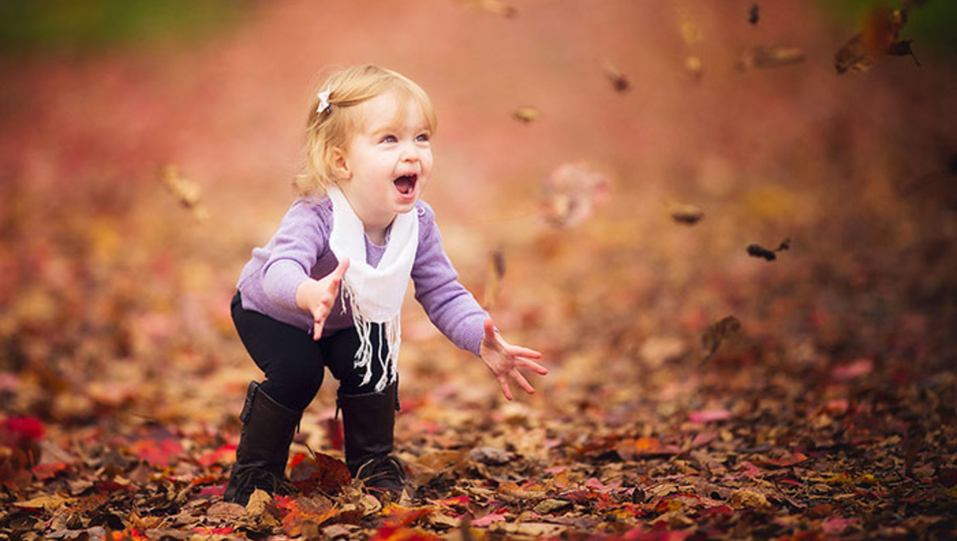

What do you see?

What season is it?

What details show us what season it is?

The girl has a long sleeve shirt on.

The girl does not have a jacket on.

There are leaves on the ground.

The leaves are red and orange.

Activities! You are welcome to do all of these activities but please do at least three of them.

1. Have your child draw and label the clothing they would wear during their favorite season.
2. Have your child write the letter P, both uppercase and lowercase, 10 times each.
3. Find a spot in the house and have your child describe the spot by giving you four to five details they see.
4. Discuss with your child their least favorite season. Have them explain to you why it is their least favorite.
5. Have your child practice these simple sight words 5 times each (come, look, you, it, to). This means to say the word, have the child say the word, and write the word.